Engineering Math. & Phys. Dept.  Faculty of Engineering  Cairo University  Giza, 12613, Egypt |  | قسم الرياضيات والفيزيقا الهندسية  كلية الهندسة  جامعة القاهرة  الجيزة –جمهورية مصر العربية

Mec645
Finite Element method in Fluid Mechanics
Instructor: Amr Guaily
Assignment No.5: Steady rotational inviscid two-dimensional flow
Due in two weeks.

Introduction:
A chemically reacting fluid flows through a 2-D channel (shown in Figure 1) of half width d. Design considerations require that the flow area of the duct be abruptly reduced to 1/10th of its size. To prevent destruction of the duct by the reacting fluid, no stagnant eddies at the contraction can be allowed. You, as a designer, have some control over the duct length upstream of the contraction, and thus the velocity profile of the fluid approaching the contraction. To solve this problem, you must somehow estimate the flow field near the contraction.

2d
d

d

Symmetry line
d/10

Figure 1: Sudden contraction

- Governing Equations

The governing equations in 2-D Cartesian coordinates for steady, inviscid rotational flow are given by Euler’s equations:

Conservation of mass:
$\frac{∂u}{∂x}+\frac{∂v}{∂y}=0$ (1)
Balance of momentum:

$u\frac{∂u}{∂x}+v\frac{∂u}{∂y}=-\frac{1}{ρ}\frac{∂p}{∂x}$ (2)
$u\frac{∂v}{∂x}+v\frac{∂v}{∂y}=-\frac{1}{ρ}\frac{∂p}{∂y}$ (3)

One way to attack the problem is by solving for the primitive variables $\left(u,v,p\right)$ considering (1), (2), and (3) and this approach will be considered later when we solve the Navier-Stokes equations. Another way is by reformulating the problem to be solved for the vorticity/stream functions which is adopted in this assignment.
Recall the vorticity definition is:
$ω=∇×U$ (4)

Where U is the velocity vector. The vorticity component in x-y plan is:

$ω=\frac{∂v}{∂x}-\frac{∂u}{∂y}$ (5)

Recalling the velocity components in terms of the stream function are:

$u=\frac{∂Ψ}{∂y}, v=-\frac{∂Ψ}{∂x}$ (6)

Where $Ψ$ is the stream function. Note that the continuity equation is automatically satisfied with this definition of the stream function. Using (6) into (5):

$∇^{2}Ψ=-ω$ (7)

To get an equation for the vorticity $ω$.
Differentiating (2) w.r.t y to get:
$u_{y}u_{x}+uu_{xy}+v_{y}u_{y}+vu_{yy}=-\frac{1}{ρ}p_{xy}$ (8)
Note that in equation (8) the first and third terms cancel out due to the continuity equation (1).
Similarly differentiating (3) w.r.t. $x$ to get:
$u_{x}v_{x}+uv_{xx}+v_{x}v_{y}+vu_{yx}=-\frac{1}{ρ}p_{yx}$ (9)
Again, note that in equation (9) the first and third terms cancel out due to the continuity equation (1).
Note that the order of differentiation is NOT important ($p_{xy}=p_{yx}$) since we have no discontinuities because we are dealing with incompressible flows. If discontinuities exist, then $p_{xy}$ is not guaranteed to equal$p_{yx}$. Subtracting (9) from (8) yields:
$u\frac{∂}{∂x}(v_{x}-u_{y})+v\frac{∂}{∂y}(v_{x}-u_{y})=0$ (10)
Using the definition of the vorticity in 2D namely, equation (5), equation (10) reads:
$u\frac{∂ω}{∂x}+v\frac{∂ω}{∂y}=0$ (11)
Since we are dealing with steady flows, adding an unsteady term to equation (11) effectively works like adding a zero,
$\frac{∂ω}{∂t}+u\frac{∂ω}{∂x}+v\frac{∂ω}{∂y}=0=\frac{Dω}{Dt}$ (12)
Equation (12) is the 2nd equation to be solved along with (7) instead of (1), (2) and (3) but we still can make it simpler by carefully reading equation (12). Equation (12) reads as follows: the total time derivative of the vorticity is zero i.e. the vorticity is conserved “constant along a streamline”.
So, from (12):
$ω=\text{constant}$ (13)

Important note: equation (13) does not mean that the vorticity is a fixed number everywhere in the domain but rather a fixed number along a streamline and differs from one streamline to another i.e. it is a function of both x and y: $ω(x,y)$. One way to determine this constant (along a streamline) is by considering the distribution of the vorticity function at the inlet using the boundary conditions.
- Boundary conditions:
The velocity at the inlet is given as:
- A very short inlet duct is equivalent to a uniform flow approaching the contraction:

$u=u_{m}; v=0$ (14)

- A very long inlet duct is equivalent to fully developed flow e.g. a cosine distribution exists at the inlet

$u=\frac{πu_{m}}{2}\cos\left(\frac{πy}{2d}\right); v=0$ (15)
where $u_{m}$is the mean axial velocity.
  - Boundary conditions in terms of the stream-function
For case (a)
$u=u_{m}; v=0, using equation \left(5\right) leads to ω=0 at the inlet$. Using (13) means that $ω=0$ everywhere in the domain. Similarly, for the stream function:
$$Ψ=-\int{v dx}=f\left(y\right)$$
$$Ψ=\int{u dy}=u_{m}y+f\left(x\right)$$
Then,
$$Ψ=u_{m}y$$
In this case equation (7) becomes:
$∇^{2}Ψ=0$ (7a)

For case (b)

Similar to case (a), using equation (5) to get the vorticity at the inlet leads to:

$$ω=\frac{∂v}{∂x}-\frac{∂u}{∂y}=\frac{∂\left(0\right)}{∂x}-\frac{∂\left(\frac{πu_{m}}{2}\cos\left(\frac{πy}{2d}\right)\right)}{∂y}=\frac{π^{2}u_{m}}{4d}\sin\left(\frac{πy}{2d}\right)$$
using equation (6) to the get the stream function at the inlet leads to:
$$Ψ=-\int{v dx}=f\left(y\right)$$
$$Ψ=\int{u dy}=\int{\frac{πu_{m}}{2}\cos\left(\frac{πy}{2d}\right) dy}=u_{m}d sin⁡(\frac{πy}{2d})+f\left(x\right)$$
Then, the vorticity and the stream function are related by:

$$Ψ=u_{m}d\sin\left(\frac{πy}{2d}\right)=\frac{4d^{2}}{π^{2}} ω$$

In this case equation (7) becomes:
$∇^{2}Ψ=-\frac{π^{2}}{4d^{2}}Ψ$ (7b)
So, combining both case, equation (7) in terms of the stream function is:

$∇^{2}Ψ=kΨ$ (7c)
and
$k=\left\{\begin{matrix}0\text{ case }(a) \\ -\frac{π^{2}}{4d^{2}}\text{ case }(b)\end{matrix}\right.$

- Non-dimensionalization:

Let $Ψ^{*}=\frac{Ψ}{u_{m}d}; x^{*}=\frac{x}{d}; y^{*}=\frac{y}{d}$ (16)
Using the relations developed using the boundary conditions, equation (7) becomes:

$∇_{*}^{2}Ψ^{*}=CΨ^{*}$ (17)
Where $∇_{*}^{2}$ is the non-dimensional Laplacian operator. and
$C=\left\{\begin{matrix}0\text{ case }(a) \\ -\frac{π^{2}}{4}\text{ case }(b)\end{matrix}\right.$ (18)
- Boundary conditions in terms of the non-dimensional stream-function
${\left.Ψ^{*}\right|}_{inlet}=\left\{\begin{matrix}y^{*}\text{ case }(a) \\ \sin\left(\frac{π}{2}y^{*}\right)\text{ case }(b) \end{matrix}\right.$
$Ψ^{*}=0$ on the axis of symmetry.
$Ψ^{*}=1$ on the upper wall.
$\frac{∂Ψ^{*}}{∂n}=0$ at the exit.
Requirements
- Classify (Hyperbolic, elliptic, parabolic) the equation to be solved, namely, equation (17).
- Obtain a finite element solution for cases (a) and (b) using bilinear (4 nodes) quadrilateral elements.
- Plot the resulting streamlines.
- Get the velocity field using the Galerkin FEM from the stream function.
- Plot the velocity field.
- For the case with long entrance:
  - find the order of accuracy, p, of the numerical scheme. You can use the location of the vortex center, where the velocity is approximately zero, as the monitoring parameter.
  - using at least 3 grids, perform a grid convergence study (GCS) and compute the grid convergence index (GCI).
  - calculate the asymptotic numerical value using the Richardson extrapolation approximation.
- Optional: calculate D where D= $\frac{∂u}{∂x}+\frac{∂v}{∂y}$ is the divergence of the velocity field. This way we are checking if the continuity equation is satisfied everywhere or not or not.
Sample Answers:
Short entrance
Long entrance
Optional but important:
Modify the code to solve the following partial differential equation
$$∇^{2}p=\frac{1}{ε}\left(\frac{∂u}{∂x}+\frac{∂v}{∂y}\right)$$
With
$$ε=0.05, \\ {\left.u\right|}_{everywhere}=0,\text{ except }{\left.u\right|}_{\text{upper }wall}=1 and u(upper right/left corner)=0.5 \\ {\left.v\right|}_{everywhere}=0$$
And the boundary condition for the pressure is
${\left.\frac{∂p}{∂n}\right|}_{\text{over all the walls}}=0$ and ${\left.p\right|}_{\text{middle point of the lower wall}}=0$
Sample result
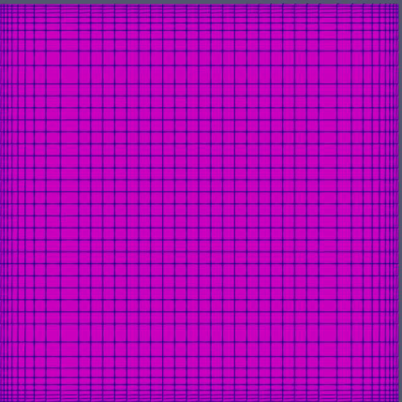 | 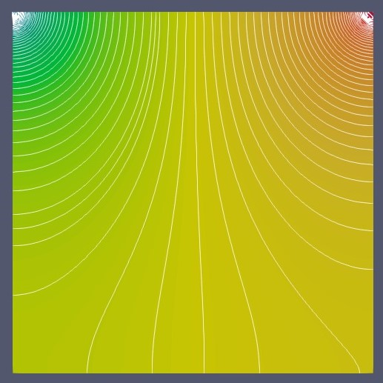
Grid | Pressure contours

